SIMATS ENGINEERING
ASSESSMENT TOOL 1
FUNDAMENTALS OF MACHINE LEARNING – MLA 02
Student Name: CHALLA RAVITEJA
Student Register No: 192325065
CO3_AT1
COURSE CODE: MLA 02
COURSE NAME: Fundamentals of Machine Learning
COURSE OUTCOME COVERED
CO2: Analyze unsupervised learning methods, including clustering and dimensionality reduction, to extract insights from unlabelled data.(BL3)
Assessment Tool Weightage: 40%
QUESTIONS:3 Total Marks:50 Annexure A
Experiments
Code of Conduct:
I __CHALLA RAVITEJA__ (Name / Reg No) certify that this submission is my original work and that I have adhered to the guidelines specified for this assessment.
I understand that any violation of academic integrity rules will result in disciplinary action. Signature of the student:
Annexure A
Experiments
1. Customer Segmentation using K-Means and PCA: Load the Mall Customers dataset and preprocess the data. Apply the K-Means algorithm to identify customer clusters, then use PCA to reduce the data to two dimensions and visualize the clusters. Analyze the optimal number of clusters using the Elbow Method and Silhouette Score.
2. Clustering using EM Algorithm and Gaussian Mixture Model: Load the Digits dataset from Scikit-learn and preprocess the features. Implement the Gaussian Mixture Model (EM Algorithm) to cluster the data and compare its performance with K-Means using appropriate clustering evaluation metrics. Visualize the clusters after applying PCA.
3. Dimensionality Reduction using PCA, Factor Analysis, and ICA: Load the Wine dataset from Scikit-learn and standardize the features. Apply Principal Component Analysis (PCA), Factor Analysis (FA), and Independent Component Analysis (ICA) to reduce the dimensionality and compare their outputs. Discuss how these techniques help address the Curse of Dimensionality through visualizations and component analysis.

RUBRICS FOR CALCULATION
 |  | Experiment
Criteria | Weightage (%) | Level 4  (Exemplary) | Level 3  (Proficient) | Level 2  (Developing) | Level 1  (Beginning)
Problem  Identification | 20% | Clearly defines  problem and  objectives with  strong relevance  and focus | Defines problem and objectives  with minor gaps | Problem or  objectives are  unclear or  partially defined | Unable to  clearly identify problem or  objectives
Experimental Planning | 25% | Designs a well  structured, logical, and feasible  methodology | Methodology is  appropriate with minor issues | Methodology  lacks clarity or completeness | No clear or  appropriate  methodology
Variable  Identification | 20% | Correctly identifies and controls all  variables effectively | Identifies most  variables with  minor errors | Identifies limited variables; weak control | Unable to  identify or  control variables
Data  Collection | 20% | Collects accurate data and performs thorough, logical  analysis | Data collection  and analysis are mostly correct | Data is  incomplete or  analysis is  superficial | Poor or no data collection and analysis
Conclusion | 15% | Draws clear, well supported  conclusions aligned with objectives | Conclusions are reasonable with minor gaps | Conclusions are weak or partially supported | Unable to draw meaningful  conclusions

EXPERIMENT 1
Customer Segmentation using K-Means and PCA

Aim
To load and preprocess the Mall Customers dataset, apply the K-Means clustering algorithm to identify customer segments, determine a suitable number of clusters using the Elbow Method and Silhouette Score, and use Principal Component Analysis (PCA) to reduce the data to two dimensions for cluster visualization.

Concept of the Program
Customer segmentation is an unsupervised learning task in which customers are grouped according to similarities in their characteristics without using predefined class labels. K-Means is a partition-based clustering algorithm that assigns each observation to the nearest cluster centroid and repeatedly updates the centroids until the assignments stabilize. In the Mall Customers dataset, variables such as age, annual income, and spending score can be used to identify groups with similar purchasing behaviour. Before clustering, numerical features should be selected and standardized so that variables measured on different scales do not dominate the distance calculation. The Elbow Method evaluates different values of K by examining the within-cluster sum of squares, also called inertia. As K increases, inertia generally decreases, and the elbow indicates a useful balance between compactness and model complexity. The Silhouette Score measures how well each observation fits its own cluster compared with neighbouring clusters. A higher average silhouette score indicates better separation and cohesion. After selecting K, K-Means is fitted to the standardized features. PCA is then used to transform the high-dimensional feature space into two principal components for visualization. PCA finds directions that capture maximum variance while producing orthogonal components. The resulting two-dimensional plot makes it easier to inspect the structure of the customer segments.

Dataset and Variables
The Mall Customers dataset generally contains customer identifiers and demographic or behavioural variables. CustomerID is an identifier and is not used as a clustering feature. For a common customer-segmentation experiment, Age, Annual Income (k$), and Spending Score (1-100) are used as numerical variables. If the supplied CSV contains additional suitable numerical attributes, they may also be selected after inspection. The target variable is absent because this is an unsupervised learning problem.

Methodology
First load the CSV file and inspect its columns, data types, missing values, and duplicate records. Select meaningful numerical features, remove identifier columns, handle missing values if present, and standardize the features. Fit K-Means for several values of K, such as 2 through 10. Record inertia for the Elbow Method and silhouette score for each K. Select a suitable K by considering both measures rather than relying on one graph alone. Fit the final K-Means model with the selected K, obtain the cluster labels, and reduce the standardized data to two PCA components. Plot the PCA representation using the cluster labels to visually inspect the segmentation.

Relevant Formulas
Euclidean distance: d(x, μₖ) = √Σⱼ(xⱼ − μₖⱼ)². K-Means objective: J = Σₖ Σₓ∈Cₖ ||x − μₖ||². Standardization: z = (x − μ) / σ. PCA projects X onto principal directions using Z = XW. Silhouette for an observation: s = (b − a) / max(a,b), where a is mean intra-cluster distance and b is mean distance to the nearest other cluster.

Pseudo Code
• START
• Load Mall Customers dataset
• Inspect and preprocess the data
• Select numerical clustering features
• Standardize the features
• For K = 2 to 10
• Apply K-Means
• Store inertia
• Calculate silhouette score
• Select suitable K using elbow and silhouette
• Fit final K-Means model
• Apply PCA with two components
• Plot clusters in PCA space
• Display cluster sizes and evaluation values
• STOP

Python Program
import pandas as pd
import matplotlib.pyplot as plt
from sklearn.preprocessing import StandardScaler
from sklearn.cluster import KMeans
from sklearn.metrics import silhouette_score
from sklearn.decomposition import PCA

# Load dataset
df = pd.read_csv("Mall_Customers.csv")

print("Dataset Shape:", df.shape)
print("\nColumns:", list(df.columns))

# Select commonly used numerical features
features = ["Age", "Annual Income (k$)", "Spending Score (1-100)"]
X = df[features].copy()

# Handle missing values
X = X.dropna()

# Standardize features
scaler = StandardScaler()
X_scaled = scaler.fit_transform(X)

# Elbow Method and Silhouette Score
inertias = []
silhouette_scores = []
k_values = range(2, 11)

for k in k_values:
model = KMeans(n_clusters=k, random_state=42, n_init=10)
labels = model.fit_predict(X_scaled)

inertias.append(model.inertia_)
silhouette_scores.append(silhouette_score(X_scaled, labels))

# Display scores
results = pd.DataFrame({
"K": list(k_values),
"Inertia": inertias,
"Silhouette Score": silhouette_scores
})
print("\nK Evaluation:")
print(results.round(4))

# Select K with highest silhouette score
best_k = list(k_values)[silhouette_scores.index(max(silhouette_scores))]
print("\nSelected K:", best_k)

# Final K-Means
kmeans = KMeans(n_clusters=best_k, random_state=42, n_init=10)
clusters = kmeans.fit_predict(X_scaled)

print("\nCluster Sizes:")
print(pd.Series(clusters).value_counts().sort_index())

# PCA to 2 dimensions
pca = PCA(n_components=2)
X_pca = pca.fit_transform(X_scaled)

print("\nExplained Variance Ratio:")
print(pca.explained_variance_ratio_)
print("Total Explained Variance:",
round(pca.explained_variance_ratio_.sum(), 4))

# PCA cluster visualization
plt.figure(figsize=(8, 6))
plt.scatter(X_pca[:, 0], X_pca[:, 1], c=clusters, s=40)
plt.xlabel("Principal Component 1")
plt.ylabel("Principal Component 2")
plt.title("Customer Segmentation using K-Means and PCA")
plt.grid(True)
plt.show()

# Elbow plot
plt.figure(figsize=(8, 5))
plt.plot(list(k_values), inertias, marker="o")
plt.xlabel("Number of Clusters (K)")
plt.ylabel("Inertia")
plt.title("Elbow Method")
plt.grid(True)
plt.show()

# Silhouette plot
plt.figure(figsize=(8, 5))
plt.plot(list(k_values), silhouette_scores, marker="o")
plt.xlabel("Number of Clusters (K)")
plt.ylabel("Silhouette Score")
plt.title("Silhouette Score")
plt.grid(True)
plt.show()

Output and Analysis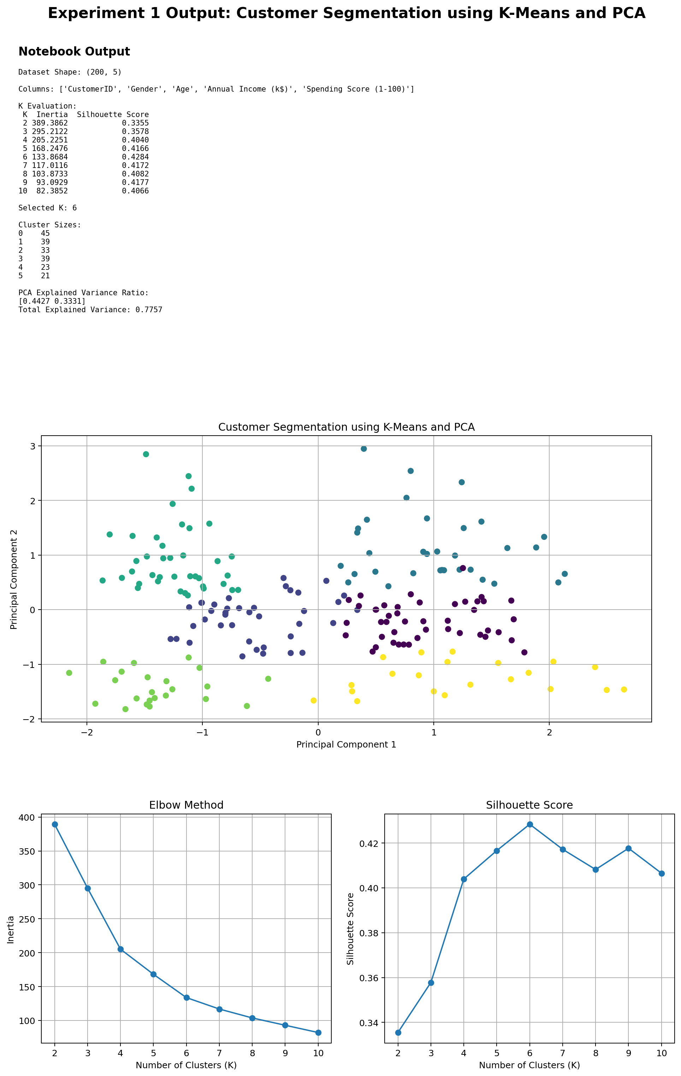

The notebook will display the dataset shape, the evaluation table for K values from 2 to 10, the selected K, cluster sizes, PCA explained-variance ratios, an Elbow plot, a Silhouette Score plot, and a two-dimensional PCA cluster plot. The selected number of clusters should be justified using the point where the Elbow curve begins to flatten and the K having a strong silhouette score. The PCA visualization should show whether the discovered customer groups are reasonably compact and separated.

Result
Thus, the Mall Customers dataset is segmented successfully using K-Means clustering. The Elbow Method and Silhouette Score are used to select a suitable number of clusters, and PCA reduces the standardized feature space to two dimensions for visualization of the identified customer segments.

EXPERIMENT 2
Clustering using EM Algorithm and Gaussian Mixture Model

Aim
To load the Digits dataset from Scikit-learn, preprocess the features, implement Gaussian Mixture Model clustering using the Expectation-Maximization (EM) algorithm, compare its clustering performance with K-Means using suitable evaluation metrics, and visualize the clusters after applying PCA.

Concept of the Program
Gaussian Mixture Model is a probabilistic clustering technique that assumes the observations are generated from a mixture of several Gaussian distributions. Unlike K-Means, which assigns each observation to exactly one cluster based on distance from a centroid, GMM estimates the probability that an observation belongs to each component. The parameters of the Gaussian components are estimated using the Expectation-Maximization algorithm. In the Expectation step, the current model parameters are used to calculate the responsibility of each Gaussian component for every observation. In the Maximization step, the component parameters are updated using these responsibilities. These two steps are repeated until convergence. The Digits dataset contains numerical pixel features representing handwritten digits. Since the dataset has ten digit classes, a GMM with ten components can be used for a direct unsupervised comparison with ten K-Means clusters, although the cluster labels themselves do not correspond numerically to the true digit labels. The comparison can therefore use internal metrics such as Silhouette Score and Calinski-Harabasz Score. PCA is applied to the standardized digit features to reduce the representation to two dimensions for visualization. The resulting plot shows the spatial structure of the clusters produced by the two algorithms. GMM can model elliptical or overlapping cluster structures because it learns covariance matrices, whereas K-Means primarily assumes compact clusters around centroids.

Dataset and Variables
The Digits dataset is available directly from scikit-learn. Each observation represents a handwritten digit image and contains 64 numerical pixel-intensity features corresponding to an 8×8 image. The target digit labels are available in the dataset, but they are not used when fitting the unsupervised clustering models. The target can be retained separately only for optional external interpretation; clustering itself uses the feature matrix.

Methodology
Load the Digits dataset using load_digits(). Standardize the pixel features so that the clustering algorithms operate on a comparable scale. Fit K-Means with ten clusters and GaussianMixture with ten components. For both models, obtain the predicted cluster labels. Calculate Silhouette Score and Calinski-Harabasz Score using the feature representation used for clustering. PCA is then used to obtain two components, and separate scatter plots are created for the K-Means and GMM labels. The model with stronger internal clustering metrics can be considered better for the selected representation, while the visualizations help explain the shape and separation of the discovered groups.

Relevant Formulas
GMM density: p(x) = Σₖ πₖ N(x | μₖ, Σₖ). Responsibility: γₖ(x) = πₖN(x|μₖ,Σₖ) / Σⱼ πⱼN(x|μⱼ,Σⱼ). K-Means objective: J = Σₖ Σₓ∈Cₖ ||x − μₖ||². Silhouette: s = (b − a) / max(a,b). PCA projection: Z = XW.

Pseudo Code
• START
• Load Digits dataset from scikit-learn
• Separate features from labels
• Standardize the feature matrix
• Apply K-Means with 10 clusters
• Apply Gaussian Mixture Model with 10 components
• Obtain cluster labels
• Calculate Silhouette and Calinski-Harabasz scores
• Apply PCA to reduce features to 2 dimensions
• Plot K-Means clusters
• Plot GMM clusters
• Compare evaluation metrics
• STOP

Python Program
import pandas as pd
import matplotlib.pyplot as plt
from sklearn.datasets import load_digits
from sklearn.preprocessing import StandardScaler
from sklearn.cluster import KMeans
from sklearn.mixture import GaussianMixture
from sklearn.decomposition import PCA
from sklearn.metrics import silhouette_score, calinski_harabasz_score

# Load Digits dataset
digits = load_digits()
X = digits.data

print("Dataset Shape:", X.shape)

# Standardize features
scaler = StandardScaler()
X_scaled = scaler.fit_transform(X)

n_clusters = 10

# K-Means
kmeans = KMeans(n_clusters=n_clusters, random_state=42, n_init=10)
kmeans_labels = kmeans.fit_predict(X_scaled)

# Gaussian Mixture Model using EM
gmm = GaussianMixture(
n_components=n_clusters,
covariance_type="full",
random_state=42
)
gmm_labels = gmm.fit_predict(X_scaled)

# Evaluation
kmeans_sil = silhouette_score(X_scaled, kmeans_labels)
gmm_sil = silhouette_score(X_scaled, gmm_labels)

kmeans_ch = calinski_harabasz_score(X_scaled, kmeans_labels)
gmm_ch = calinski_harabasz_score(X_scaled, gmm_labels)

comparison = pd.DataFrame({
"Model": ["K-Means", "Gaussian Mixture Model"],
"Silhouette Score": [kmeans_sil, gmm_sil],
"Calinski-Harabasz Score": [kmeans_ch, gmm_ch]
})

print("\nClustering Comparison:")
print(comparison.round(4))

# PCA visualization
pca = PCA(n_components=2)
X_pca = pca.fit_transform(X_scaled)

print("\nPCA Explained Variance Ratio:")
print(pca.explained_variance_ratio_)
print("Total Explained Variance:",
round(pca.explained_variance_ratio_.sum(), 4))

# K-Means visualization
plt.figure(figsize=(8, 6))
plt.scatter(X_pca[:, 0], X_pca[:, 1], c=kmeans_labels, s=12)
plt.xlabel("Principal Component 1")
plt.ylabel("Principal Component 2")
plt.title("Digits Clustering using K-Means")
plt.grid(True)
plt.show()

# GMM visualization
plt.figure(figsize=(8, 6))
plt.scatter(X_pca[:, 0], X_pca[:, 1], c=gmm_labels, s=12)
plt.xlabel("Principal Component 1")
plt.ylabel("Principal Component 2")
plt.title("Digits Clustering using Gaussian Mixture Model")
plt.grid(True)
plt.show()

# Final comparison
if gmm_sil > kmeans_sil:
print("\nBased on Silhouette Score: GMM performs better.")
else:
print("\nBased on Silhouette Score: K-Means performs better.")

Output and Analysis
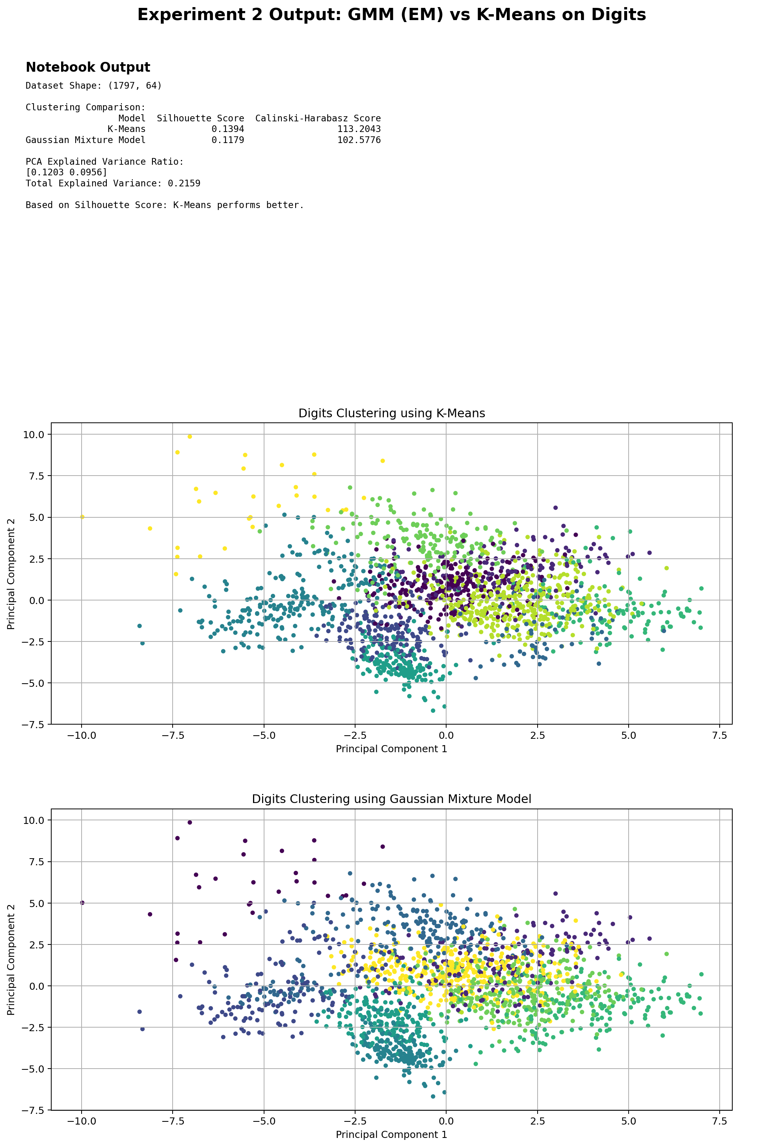
The program displays the Digits dataset shape, Silhouette Score, Calinski-Harabasz Score, PCA explained variance, and two cluster visualizations. The comparison table allows the clustering quality of K-Means and GMM to be assessed. A higher Silhouette Score generally indicates better cohesion and separation, while a higher Calinski-Harabasz Score indicates a more compact and well-separated clustering structure. The final choice should be based on the observed metrics rather than assuming that one algorithm is always superior.

Result
Thus, the Digits dataset is clustered using both K-Means and the Gaussian Mixture Model based on the EM algorithm. Their clustering performance is compared using internal evaluation metrics, and PCA is used to visualize the resulting clusters in two dimensions.

EXPERIMENT 3
Dimensionality Reduction using PCA, Factor Analysis, and ICA

Aim
To load the Wine dataset from Scikit-learn, standardize its features, apply Principal Component Analysis (PCA), Factor Analysis (FA), and Independent Component Analysis (ICA) for dimensionality reduction, compare their outputs, and explain how these methods help address the Curse of Dimensionality through visualizations and component analysis.

Concept of the Program
Dimensionality reduction transforms a dataset with many input variables into a smaller representation while attempting to preserve useful information. The Wine dataset contains multiple chemical measurements for wine samples, making it suitable for comparing different reduction techniques. Standardization is important because the original features have different numerical scales. PCA is a variance-maximizing linear transformation that creates orthogonal principal components ordered by the amount of variance they explain. The first principal component captures the largest possible variance, while later components capture remaining variance subject to orthogonality. Factor Analysis models observed variables as combinations of a smaller number of latent factors plus unique noise. It is therefore useful when the goal is to represent hidden underlying factors rather than simply maximize total variance. Independent Component Analysis seeks statistically independent components and is based on the idea that observed data may be mixtures of underlying independent sources. PCA, FA, and ICA can all reduce the number of dimensions, but they optimize different objectives and therefore may produce different component representations. Reducing dimensionality can decrease computational cost, reduce redundancy, improve visualization, and sometimes reduce the effect of noise. It can also help address the Curse of Dimensionality by representing the data in a smaller feature space. However, dimensionality reduction can discard information, so the retained variance, reconstruction quality, or downstream performance should be examined when selecting a representation.

Dataset and Variables
The Wine dataset is available from scikit-learn and contains 13 numerical chemical features for 178 wine samples. The dataset also contains three class labels, but PCA, Factor Analysis, and ICA are applied to the feature matrix without using the labels to learn the reduced representation. The labels may be used only for optional visualization after transformation if class-based interpretation is desired.

Methodology
Load the Wine dataset and standardize the 13 numerical features. Apply PCA with two components for two-dimensional visualization and calculate the explained variance ratio and cumulative explained variance. Apply Factor Analysis with two components and transform the standardized data. Apply FastICA with two components and transform the same standardized data. Compare the shape and spread of the transformed representations using scatter plots. PCA can additionally report explained variance, while FA and ICA should be compared based on their component structure and visual representation because their components do not have the same variance-based interpretation as PCA.

Relevant Formulas
Standardization: z = (x − μ) / σ. PCA covariance matrix: S = (1/(n−1))XᵀX. PCA projection: Z = XW. Explained variance ratio for component i: EVRᵢ = λᵢ / Σⱼλⱼ. Factor Analysis model: X = ΛF + ε. ICA model: X = AS, where X is the observed data, A is the mixing matrix, and S contains statistically independent components.

Pseudo Code
• START
• Load Wine dataset from scikit-learn
• Extract numerical features
• Standardize all features
• Apply PCA with 2 components
• Record explained variance
• Apply Factor Analysis with 2 components
• Apply ICA with 2 components
• Transform the dataset using each method
• Visualize PCA, FA, and ICA outputs
• Compare component representations
• Discuss dimensionality reduction and Curse of Dimensionality
• STOP

Python Program
import numpy as np
import pandas as pd
import matplotlib.pyplot as plt

from sklearn.datasets import load_wine
from sklearn.preprocessing import StandardScaler
from sklearn.decomposition import PCA, FactorAnalysis, FastICA

# Load Wine dataset
wine = load_wine()
X = wine.data
y = wine.target

print("Dataset Shape:", X.shape)
print("Number of Original Features:", X.shape[1])

# Standardize features
scaler = StandardScaler()
X_scaled = scaler.fit_transform(X)

# PCA
pca = PCA(n_components=2)
X_pca = pca.fit_transform(X_scaled)

# Factor Analysis
fa = FactorAnalysis(n_components=2, random_state=42)
X_fa = fa.fit_transform(X_scaled)

# ICA
ica = FastICA(
n_components=2,
random_state=42,
max_iter=2000,
whiten="unit-variance"
)
X_ica = ica.fit_transform(X_scaled)

# PCA information
print("\nPCA Explained Variance Ratio:")
print(np.round(pca.explained_variance_ratio_, 4))

print("PCA Total Explained Variance:",
round(pca.explained_variance_ratio_.sum(), 4))

print("\nPCA Components:")
print(np.round(pca.components_, 4))

print("\nFactor Analysis Component Shape:")
print(fa.components_.shape)

print("ICA Component Shape:")
print(ica.components_.shape)

# Create comparison table
comparison = pd.DataFrame({
"Method": ["PCA", "Factor Analysis", "ICA"],
"Component 1 Std": [
np.std(X_pca[:, 0]),
np.std(X_fa[:, 0]),
np.std(X_ica[:, 0])
],
"Component 2 Std": [
np.std(X_pca[:, 1]),
np.std(X_fa[:, 1]),
np.std(X_ica[:, 1])
]
})

print("\nComponent Comparison:")
print(comparison.round(4))

# PCA visualization
plt.figure(figsize=(8, 6))
plt.scatter(X_pca[:, 0], X_pca[:, 1], c=y, s=35)
plt.xlabel("PCA Component 1")
plt.ylabel("PCA Component 2")
plt.title("Wine Dataset - PCA")
plt.grid(True)
plt.show()

# Factor Analysis visualization
plt.figure(figsize=(8, 6))
plt.scatter(X_fa[:, 0], X_fa[:, 1], c=y, s=35)
plt.xlabel("Factor 1")
plt.ylabel("Factor 2")
plt.title("Wine Dataset - Factor Analysis")
plt.grid(True)
plt.show()

# ICA visualization
plt.figure(figsize=(8, 6))
plt.scatter(X_ica[:, 0], X_ica[:, 1], c=y, s=35)
plt.xlabel("Independent Component 1")
plt.ylabel("Independent Component 2")
plt.title("Wine Dataset - ICA")
plt.grid(True)
plt.show()

Output and Analysis
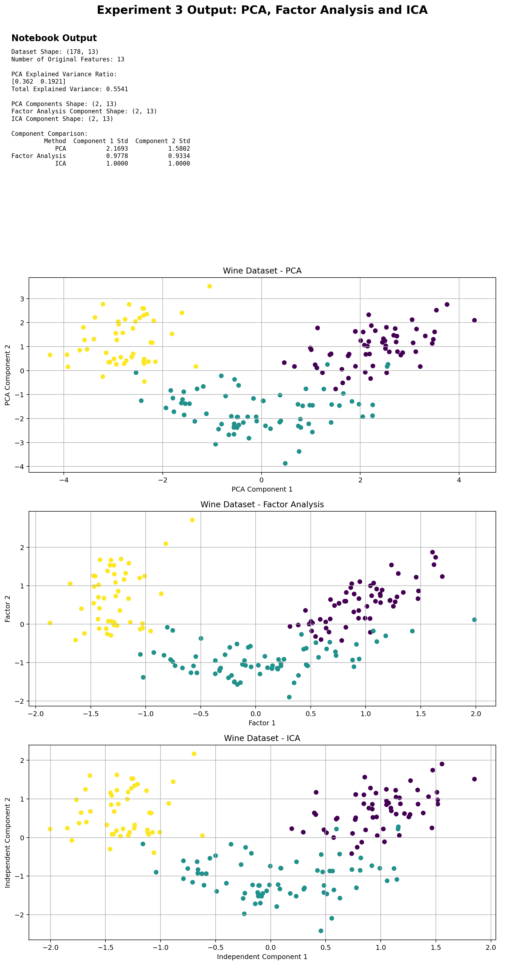
The program displays the Wine dataset dimensions, PCA explained variance ratio, total variance explained by the two PCA components, component matrices, and a comparison of the transformed representations. Three scatter plots show the Wine samples after PCA, Factor Analysis, and ICA. The plots may show different orientations and scales because each technique optimizes a different objective. PCA is directly interpretable through explained variance. FA focuses on latent factors and shared variance, while ICA searches for statistically independent components. The dimensionality is reduced from 13 features to 2 components for visualization, making the data easier to inspect and reducing the number of variables used by a downstream model.

Result
Thus, PCA, Factor Analysis, and ICA are successfully applied to the standardized Wine dataset. Their reduced representations are compared through component analysis and visualizations. The experiment demonstrates how dimensionality reduction can simplify high-dimensional data and help address the Curse of Dimensionality while retaining useful structure.

